SYNCHRONIZED TRAFFIC SIGNALS AT VARIOUS JUNCTIONS USING PIC MICROCONTROLLER

ABSTRACT

The objective of this project is to synchronize traffic lights at each junction in such a way that the traffic moving at a specific speed always gets a green light, so that it never stops.
Due to rapid urbanization and increase in population, the traffic congestion has also increased in all major cities. This has become a major problem affecting everybody.
Due to unplanned traffic management and sticking to outdated methods, problem has only deteriorated.
In this proposed system multiple microcontrollers are used. They communicate with each other via serial communication. Three microcontrollers are used to synchronize the traffic lights at three junctions. Each microcontroller is responsible for one particular junction. If the vehicles are assumed to travel at a particular speed, then the traffic signals change in such a way, that the vehicle gets green signal which results in less traffic congestion.
This kind of technology is used in modern automobiles where multiple microcontrollers are used, as the number of microcontrollers increase, the communication between them becomes essential for collective decision. For communication among themselves serial communication is preferred and a lot of serial buses and protocols were developed optimizing different parameters of the communication.
The major advantage of adopting this technology is that, there is no need for any centralized body to monitor the direction of traffic flow. As human involvement is negligible, there will be little scope of human error.
Hence, this approach is boon for government and local authorities facing financial constraints as they can’t spend money on costly cameras and software.
BLOCK DIAGRAM
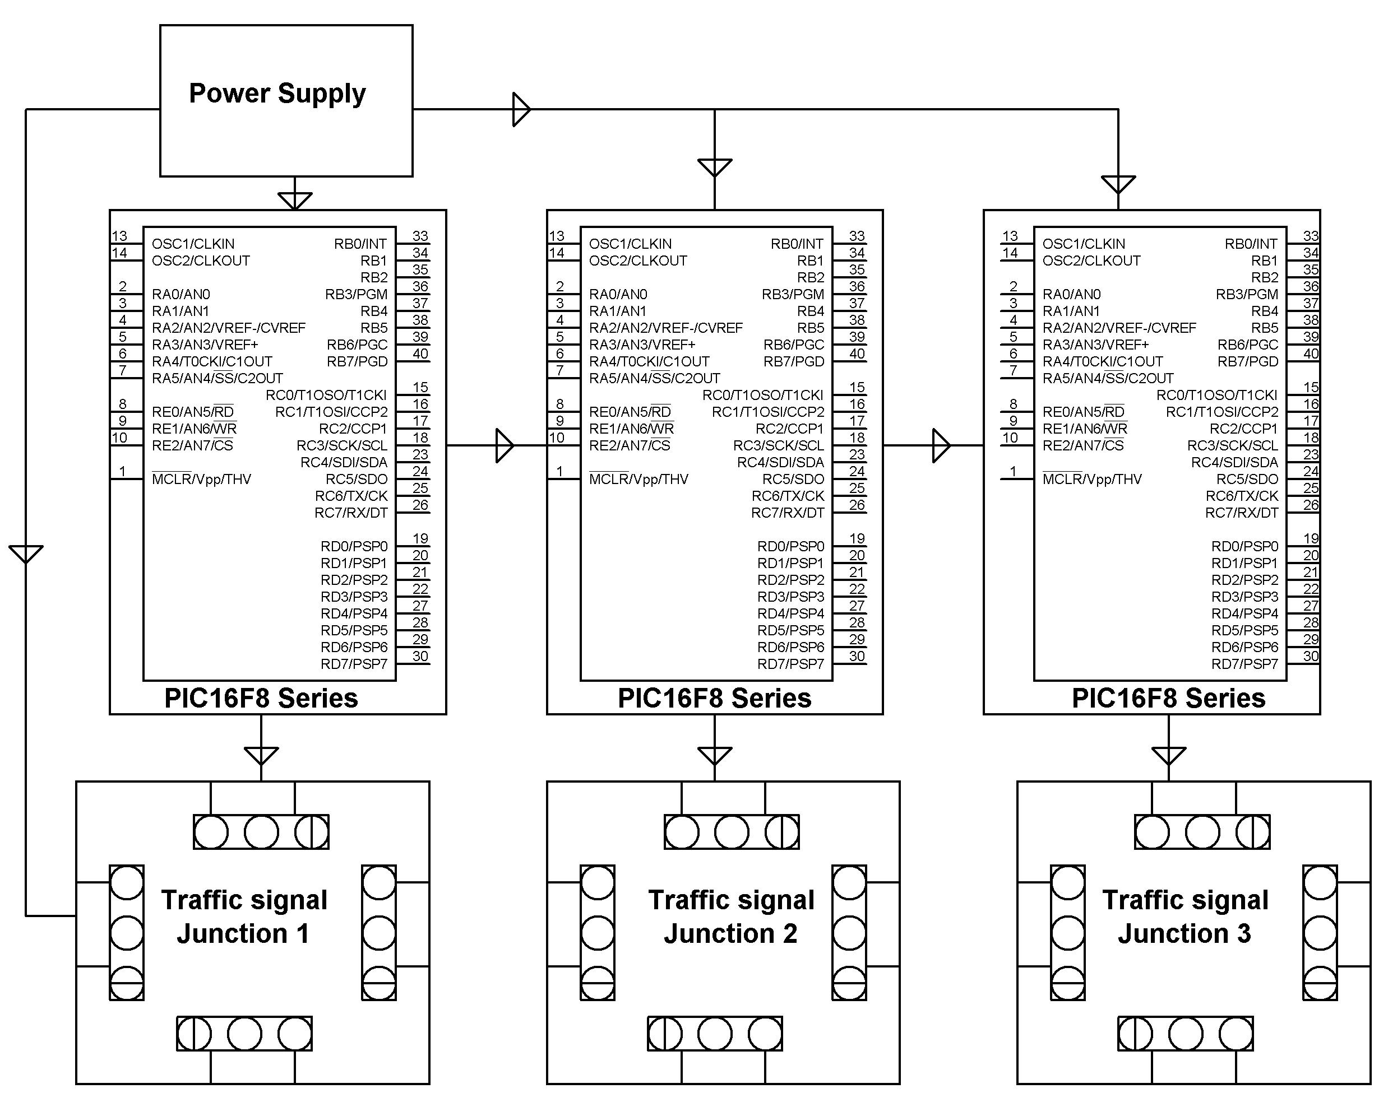

HARDWARE REQUIREMENTS:

PIC16F8 Series MC, Crystal, LEDs, Resistors, Capacitors, Diodes, Transformer, Voltage Regulator.
SOFTWARE REQUIREMENTS:

MPLAB & CCS C compiler

Language: Embedded C or Assembly.

